FPIAA: Finding Persons Inside ATLAS Areas
A System for finding and rescuing persons in a very large Physics experiment

Gianpaolo Benincasa
CERN-Geneva-Switzerland
gianpaolo.benincasa@cern.ch

David Claudino, Carlos Cardeira
IDMEC/IST, Technical University of Lisbon-Portugal
dspa@mega.ist.utl.pt, carlos.cardeira@ist.utl.pt

Amélia Maio, CFNUL and FCUL
LIP-Lisbon-Portugal
amelia@lip.pt

Abstract

ATLAS is a high energy particle detector of unprecedented size and complexity that is under construction at CERN, in the Geneva area. The detector is housed in a cavern of about 50000 m³ at 100 m under ground. The principles of the detection used in ATLAS present a combination of multiple hazards: intense radiation fields, strong magnetic fields, toxic and explosive gases, cryogenic fluids (Argon, Nitrogen and Helium), laser beams etc…
During the maintenance periods it is expected that up to 150 people could be present in the cavern at the same time, most of them working inside the intricacies of the detector and completely hidden and invisible from outside. In case of emergency, especially if smoke or fog (leaks of cryogenic fluids) are present, it could be extremely difficult and dangerously long for a rescue team to locate every person who could be in danger.
Under these circumstances, a granular system for finding persons is then mandatory. The system must cope with the harsh environment and must be totally passive (no badges or other active equipment should be worn) to avoid voluntary or casual deactivation. FPIAA (Finding Persons Inside ATLAS Areas) is based on a large number (at the present about 400) of PIR (Passive InfraRed) sensors, each one detecting the presence of a person in a relatively small volume (~ 30 m³) and distributed to cover the most critical locations in the cavern. These sensors, and all the acquisition system, have been tested, modified and retested to cope with the intense radiation and magnetic fields of the environment.
The information is collected by a computer system and, after an appropriate treatment, is sent to the Control Room where the operator can follow on a synoptic screen the movements of the persons in the cavern and inside ATLAS. The system will also give an alarm when a person disappears from a given volume, without re-appearing in one of the adjacent volumes (e.g. unconscious person).
For this, special software has been written that is susceptible to solve dubious cases, so reducing false alarms. A pilot project has already been implemented that has demonstrated the feasibility of the main features of the FPIAA system.

1 Introduction
CERN is the European Organization for Nuclear Research, the world's largest particle physics centre. Here physicists come to explore what matter is made of and what forces hold it together. CERN exists primarily to provide them with the necessary tools. These are accelerators, which accelerate particles to almost the speed of light and detectors to make the particles visible. Founded in 1954, the laboratory was one of Europe's first joint ventures and includes now 20 Member States. CERN is positioned near the Geneva Lake and extends on both sides across the Swiss-French frontier (see Photo 1). At the present time the CERN staff amounts at about 3000 persons, composed essentially of physicists, engineers and technicians, but to this number must be added about 7000 users, essentially physicists coming from all over the world and who participate to the various experiments and projects.
The most important project under development is the so called LHC (Large Hadron Collider): inside an underground tunnel of about 27 Km, two intense proton beams run in opposed directions and are accelerated at the very high energy of 7 TeV. The two beams run parallel each other, except in four positions where they collide, producing new particles. At each one of the four collision points, there are installed huge and complex particle detectors which permit to investigate the intimate constitution of the matter.
The biggest and more complex of these detectors is called ATLAS (Fig . 1).

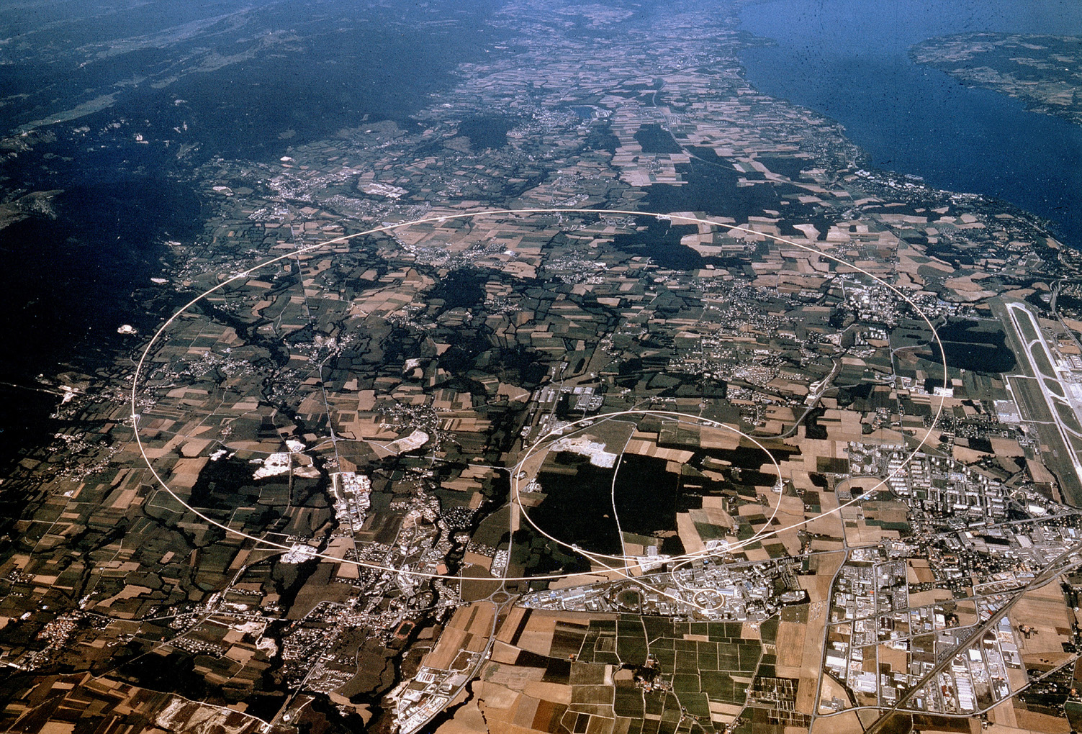

Photo 1 – CERN and LHC line in the Geneva landscape

2 The ATLAS particle detector

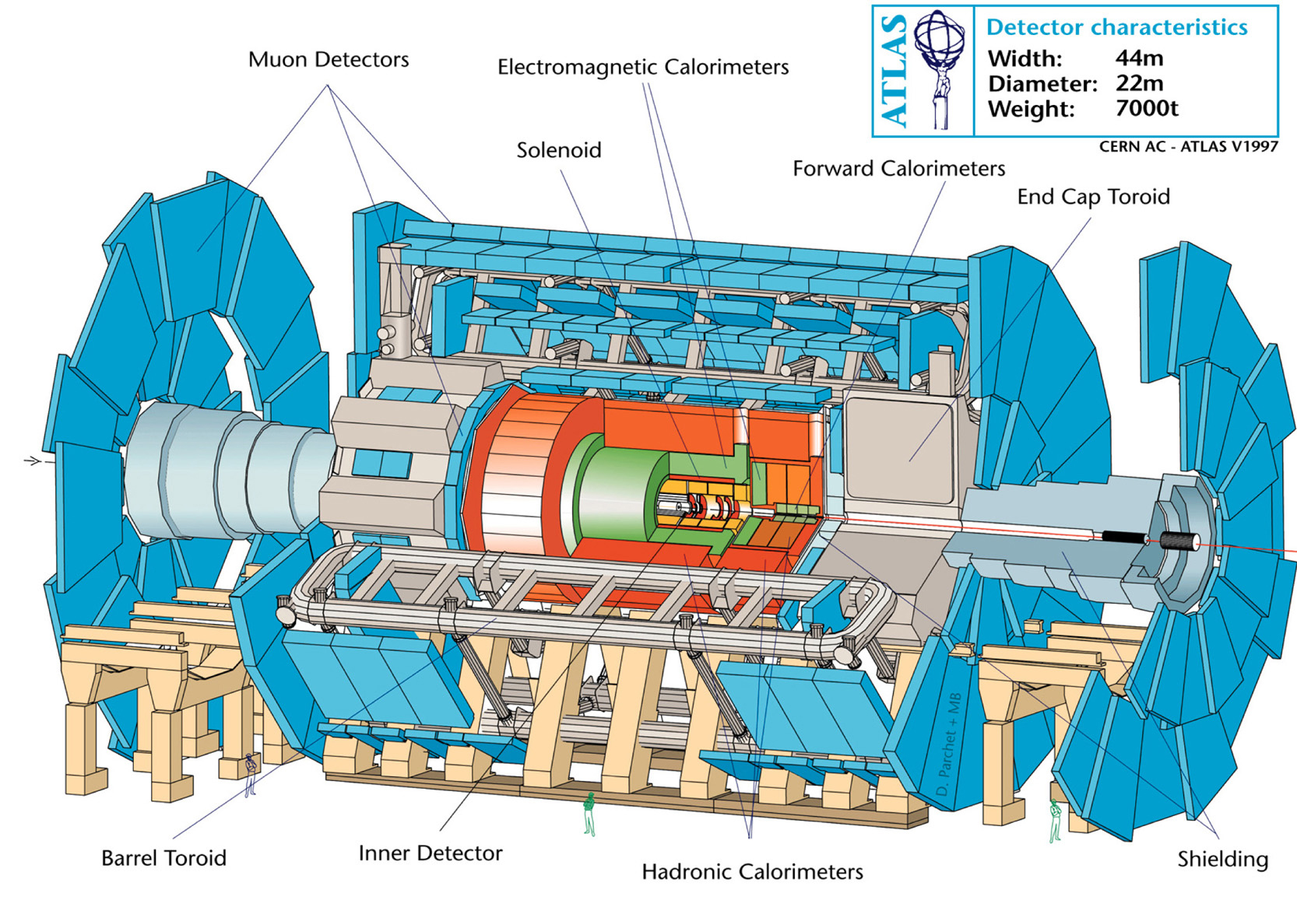
Fig 1- Cut view of the ATLAS detector

ATLAS is a huge, highly complex physics detector, to a large extent using unconventional and technologically advanced components. The detector is housed in a cavern at about 100 m under the surface and having an approximate volume of 55×30×30 cubic meters. The detector itself looks like a large cylinder of 24m diameter and about 35m length, supported by nine pairs of steel feet; its total weight is of 7000 tons. ATLAS is composed of various concentric, independent sub-detectors, positioned as in a Russian doll, each one based on a different principle of detection and each one performing a specific type of measurement [Atlas 1994]. The outermost sub-detector is formed by three layers of muon chambers, the more external being positioned at a radius of 11m. On both sides of the barrel there are two movable end cap extensions which extend longitudinally for 3.25 m each. In case of necessity (maintenance, repair...) the movable parts of the detector can be extracted using appropriate tools, so providing access inside ATLAS.
The detection principles used in ATLAS produce several kinds of risks for persons. Amongst others we recall the large quantities of cryogenic fluids (liquid Argon, liquid Nitrogen and liquid Helium), suffocating and explosive gases, fire, high voltages, thousands of Laser beams for alignment and calibration, ionizing radiations, magnetic fields [Kate 1999], etc. Despite the meticulous care that has been put in the design and implementation of the alarms and safety systems, a mishap is always possible and a particular attention must then be devoted to the problem of the rapidity of intervention.

3 Where persons could be
For economical reasons, the regions around ATLAS in the cavern, are extremely exiguous and are largely filled with equipment and services. As one can see in Fig 3 there are gangways, stairs, cranes access etc., where people could be for maintenance and repair purposes. Particular attention must be devoted to the floor; in fact, in case of cryogenic fluid leakages (especially liquid Argon), cold, dense and heavy fog will be formed on the floor and will quickly expand.
During the maintenance periods, tens (up to more than one hundred) of specialists will enter into the cavern for verifications, checking or repairing activities. Unlike other big Experiments, it will be possible and necessary to penetrate inside ATLAS hidden regions, completely not visible from outside and where crawling is a more appropriate term than walking. Moreover the hidden paths inside these regions can be several tens of meters long, so a person could have to be working very far from his entering position. Fig.2 shows some of the possible positions where persons could be. A reliable access system exists that provides at any moment precise information on the total number of persons present in the cavern: however no information exists on where these persons are located. In case of urgency (smoke, gas leakage, cryogenic leakage, etc…) an evacuation signal will urge people to leave the cavern: however if the number of exiting people does not match with the number of present persons, it would be extremely difficult and dangerously long for the rescue team to find a person in this maze. It is then essential to know at each moment where the persons are inside ATLAS and especially inside the most dangerous regions in the cavern.
This information will be provided by the FPIAA system. A minimum requirement for the FPIAA is the coverage of the following zones: the regions inside ATLAS accessible by persons (Fig. 2); the two regions at the extremities of the cavern (Fig 3); the floor of the cavern; the gangways on the lateral walls of the cavern
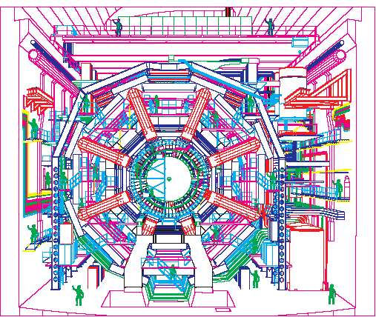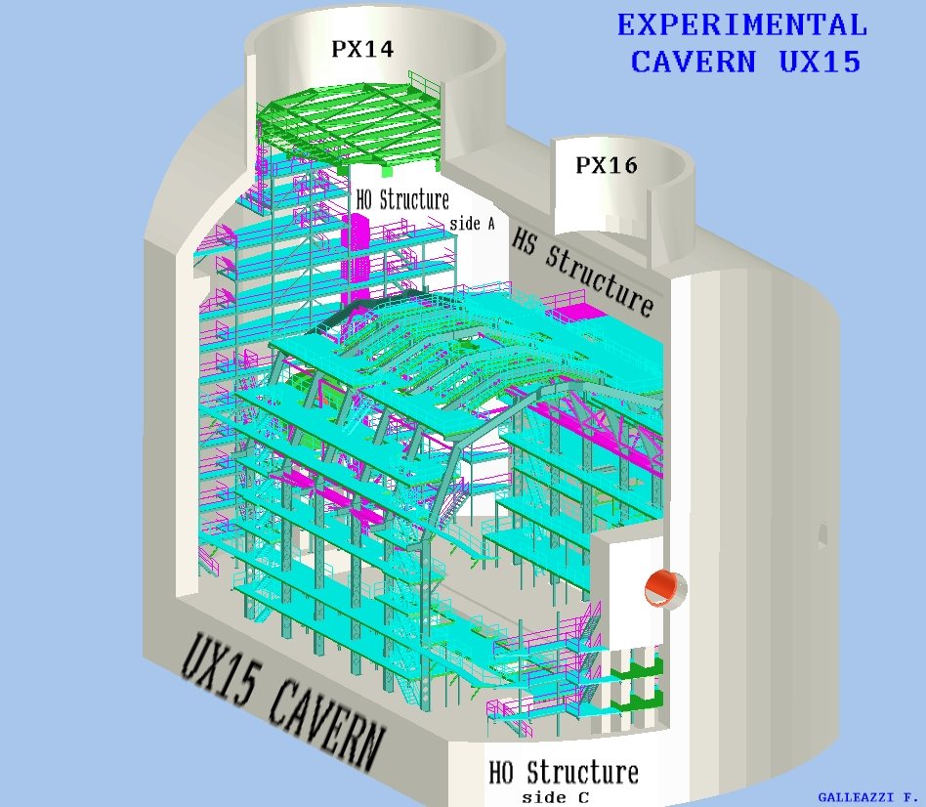

Fig 2 Accessible regions Fig 3 ATLAS cavern

4 Constraints and precision of a FPIAA system
The major constraint for a FPIAA system is certainly represented by the presence of large quantities of metallic material which could prevent the propagation of electromagnetic signals. Apart from the feet and the main support structures and rails, which are made of stainless steel, most of the ATLAS parts are made of various metals. During the design phase of the project, one of the major specifications was the possibility to identify the persons by name (“who” is in that area). Various alternatives were investigated: most of them used a transmitter-receiver technique that resulted or too expensive, or not compatible with the environment constraints. So the idea of identification by name was abandoned and we limited the requirement to a simpler person detection (“a” person is in that area). This restriction is not fundamental from the point of view of the security. The final design specifications have then been the following:
- Sensitivity: The system should detect a person in a cubic volume of approx. 30m3.
- Metallic environment: The system will work in an environment which will highly absorb electromagnetic waves: no long distance transmission/reception can be used.
- Electromagnetic fields: The very delicate Atlas systems electronics do not permit the use of FPIAA generating electromagnetic interferences: no intense microwaves sources can be used.
- Magnetic field: The FPIAA device must work inside a very intense magnetic field (2 T).
- Radiation field: The FPIAA devices must work in the Atlas medium/soft ionization field (see below).
- User friendliness: If possible, no special device should be worn by the user (could hamper his work and could be forgotten…)
The previous considerations have oriented our choice on two types of detectors: the Ultrasonic or Passive Infrared (PIR) devices. They are the only ones to fulfil all the requirements contained in the specifications. In TABLE 1 the main performances of these detectors are reported, together with those of a microwaves based system, for comparison. The regions concerned have then been divided in small cells, each one provided with a detector which will monitor the presence of a person in the specific cell. The signals coming from all the cells will be treated by a computer and a synoptic will be presented in Control Room where coloured cells will indicate, on an ATLAS map, the positions of the various persons.
However, this system presents an important drawback: both the PIR and Ultrasonic detectors can only detect moving persons. In the case a person is unconscious or, worst, is dead, the signal from the cell concerned will simply disappear. This problem can be solved by using appropriate software: most of the cells are contiguous each other, at least in the more dangerous regions, so if a person disappears from a cell without re-appearing in a contiguous cell, an alarm can be produced.

EFFECT OF ENVIRONMENTAL VARIABLES ON VOLUMETRIC DETECTORS
(The matrix does not present absolutes and is only intended as a guide for comparison)
Variable | Ultrasonic | Passive infrared | Microwave
Vibration | No problem with balanced processing, | Very few problems | Can be a major problem
 | some problems with
 | unbalanced
Effect of temperature change on range | A little | A lot | None
Effect of humidity change on range | Some | None | None
Reflection of area of coverage by large | Very little | None, unless metal | Can be a major
metal objects |  | is highly polished | problem
Reduction of range by drapes, carpets, etc. | Some | None | None
Sensitivity to movement of overhead | Needs careful | Very few problems | Can be a major
doors | placement |  | problem
Sensitivity to small animals | Problem if animals | Problem if animals | Problem if animals
 | close | close but can be | close
 |  | aimed so beams are
 |  | well above floor
Water movement in plastic storm drain pipes | No problem | No problem | Can be a problem if very close
Water noise from faulty valves | Can be a problem, very rare | No problem | No problem
Movement through thin walls or glass | No problem | No problem
Drafts, air movement | Needs careful placement | No problem
Sun, moving headlights through windows | No problem | Needs careful
 |  | placement
Ultrasonic noise | Bells, hissing, some | No problem | No problem
 | inaudible noises can
 | cause problems

TABLE1- Comparison of performances (cont.)
EFFECT OF ENVIRONMENTAL VARIABLES ON VOLUMETRIC DETECTORS (cont.)
(The matrix does not present absolutes and is only intended as a guide for comparison)
Variable | Ultrasonic | Passive infrared | Microwave
Heaters | Problem only in | Needs careful | No problem
 | extreme cases | placement
Moving machinery, fan blades | Needs careful placement | Very little problem | Needs careful placement
Radio interference, AC line transients | Can be a problem in | Can be a problem | Can be a problem
 | severe cases | in severe cases | in severe cases
Piping of detection field to | No problem | No problem
unexpected areas by A/C ducting
Radar interference | Very few problems | Very few problems
Range adjustment required | Yes | No | Yes
Current consumption (size of battery | In between
required for extended standby power)
Interference between two or more | Must be
sensors | synchronized

TABLE1- Comparison of performances (cont.)

5 Selection of an appropriate detector
PIR and US detectors, one can find on the market, usually do not comply with the severe constraints existing in the ATLAS environment: the intense ionizing radiation field. Computer simulations, based on 20 years of operation at full intensity, have produced the following integrated figures for the fluencies and absorbed doses in the most critical regions.
- 1.4 × 10¹² n/cm² of high energy neutrons (above 1 MeV)
- 60 Gy of gamma dose
- Magnetic field that reaches a value of 2 T in certain regions where some of the FPIAA detectors must be positioned.

5.1 Modification of existing detectors
In the beginning of FPIAA project, two sensors types where tested to see their radiation hardness:
- One Infrared sensor hereafter known as the PIR sensor (Aritech EV136-P)
- One dual technology sensor, composed by an Infrared sensor and a ultrasonic sensor hereafter known as the US sensor (Aritech DD325-P)

5.2 Sensors radhardness test.

a) First Irradiation Tests
Both sensors were submitted to irradiation tests in the Lisbon nuclear reactor. Due to some uncertainties in the reactor, the actual radiation levels in the reactor are not exactly the same as the target values. In this case, the dosimeter placed close to the sensor indicated that they were submitted to the following irradiation levels:

- fast neutron fluence------------------------1.4 × 10¹² n/cm2
- epithermal neutrons------------------------2.8 × 10¹² n/cm2
- gamma dose --------------------------------60 Gy

Both sensors passed the irradiation test.

b) First Magnetic Tests
After the irradiation tests, magnetic tests were made at CERN, in the H8 test beam areas, using the so-called Morpurgo magnet, a SC magnet that can produce a maximum field of 1.56 T.

Both sensors did not pass the test. Very early on the process of increasing the magnetic field the sensors stopped working.

c) Sensors Modification
A careful exam of the sensors hardware showed the existence of a relay to drive the output signal. Hence, the relay was replaced in both sensors by a LH1540ACD solid state relay and new magnetic tests were made.

d) Second Magnetic Tests
The second phase of magnetic tests, with the sensors modified, took place in Lisbon in a MRI (Magnetic Resonance Imaging) clinic.

The modified sensors passed the test in the MRI magnetic field (1.5 T)

e) Second Irradiation tests
As the sensors were modified, we made a new irradiation test to see if the solid state relay was radhard. The US (the PIR sensor had the same component) sensor was submitted to the same level of irradiation indicated on the first irradiation test.
The US sensor did not resist to the irradiation test.

f) Second hardware modifications and tests
CERN has a standard radhard DCS system [Burckhart 1998] which uses ELMB cards to acquire the signals. ELMB were developed at CERN and all the components are radhard [Burckhart 2001]. The ELMB has some optocouplers. Hence, we modified the PIR sensor to accommodate the ELMB sort of optocoupler instead the one that we used to replace the relay. The PIR sensor works fine with the ELMB optocoupler.

g) Third irradiation tests
The resisting PIR sensor (already with the ELMB optocoupler) was submitted to another set of progressive irradiation tests. Moreover, 4 more sensors (C&K Systems) were acquired and tested in the same conditions.
The irradiation plan was the following:

- Epythermal (>100KeV) m × 10¹² n/cm² with m= 2, 3, 4, 5, 10
- Fast neutrons fluence (>1 MeV) m × 0.5 × 10¹² n/cm² with m= 2, 3, 4, 5, 10

The actual figures were slightly different from the planned ones.

The 4 new sensors from C & K SYSTEMS did not resist to the irradiations. The PIR sensor resisted to the fourth irradiation with accumulated neutron (E > 1 MeV) fluence of 5.6x10¹² neutrons/cm^{2,} , a neutron (E>0.1 MeV) fluence of 1.0x10¹³ neutrons/cm² and accumulated gamma doses of 67.1 Gy.

The PIR sensor has simple electronics architecture. Meanwhile the C & K SYSTEMS sensors have some additional “intelligent” electronics that avoid false alarms. This increase of electronics might be in the origin of their lower resistance to irradiations.

Conclusion
The tested PIR sensor stood a fluency above the requirements. It has then been selected for the final design of the FPIAA system

6. Geographical distribution of sensors in the ATLAS Cavern
The FPIAA system does not cover the totality of the cavern: it covers only the most dangerous regions. However it is easily expandable.
The protected regions are:
- 2 regions for the structures on the long walls (~120 PIR)
- 2 regions for the structures on the short walls (~80 PIR)
- 1 region for the floor of the cavern (~20 PIR)
- 1 region for the ATLAS detector itself (~160 PIR)

7. The Prototype
In order to check the principal features of the FPIAA system, a prototype was built and tested. It is composed by a hardware and software layouts and, for completeness, it includes a certain number of features that, probably, will not be part of the final implementation: this is the case of some US (Ultrasonic) detectors and the use of some Webcam.

7.1. Hardware Layout

Components:
Fig 4 presents the hardware layout.
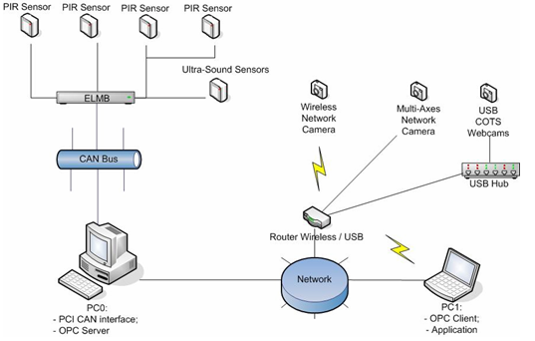

Fig. 4. Hardware layout

Passive Infra-Red (PIR) Sensors – also designated as pyroelectric sensors, they work by detecting and amplifying the electric signal emanated from a substrate when hit by light in the infra-red wavelength range.
Ultra-sound Sensors – this kind of sensors shares the same working principle with the commonly known RADAR system: ultra-sonic pulses are emitted to the environment and a return eco is then received, normalized and analysed.
ELMB – The Embedded Local Monitor Board (ELMB) is a general-purpose plug-on I/O module used in CERN distributed applications. The ELMB is based on the industry standard CANBus and therefore its connection to the field bus is granted using CANOpen. The module itself has typically 64 analogue 16 bits input channels. Smaller versions have 16 digital input channels and 16 digital output channels.
CANBus – The Controller Area Network is a high-integrity capable serial communications bus for real-time control applications. It has excellent error detection and confinement capabilities and it operates at data rates of up to 1 Mbit/sec. For reference, CAN is documented in ISO 11898 and ISO 11519 (for up to 1 Mbit/sec applications and up to 125 Kbit/sec applications respectively).
PC0 – This is a PC type desktop computer where the PCI CAN Card Interface is going to be installed on, so that it can be connected to the CANBus. Also it will be connected to the local web via PCI Ethernet Network Card.
PC1 – This is the computer where the control application will run on. To be able to access the OPC Server on PC0, it will have to be connected to the local web via Ethernet Network Interface.

7.2. Software Modules

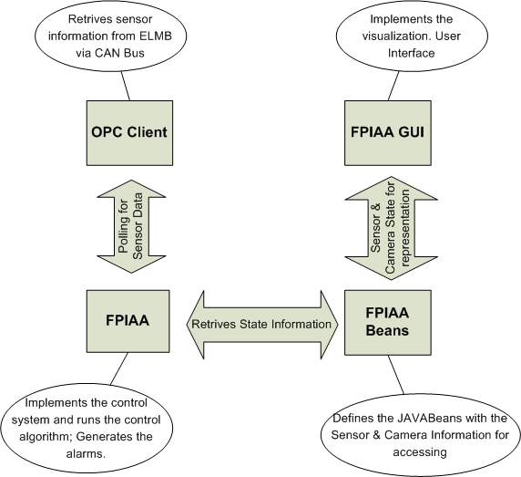
Fig. 5. Software modules

Basic Components:
The basic software components necessary to the full functioning of the FPIAA project can be resumed to the OPC Server (CANOpen OPC Server+ DA 2.0), an integrated OPC Client and the FPIAA Software Application.
Starting up with the FPIAA Software Application, this is a Java application, composed by tree basic logical modules:
FPIAA – Implements the control system. It’s in this module that all the situations of alarm, pre-alarm and end of alarm are treated and resolved. It accomplishes it by monitoring the state of the sensors. The alarms are sent to the FPIAA GUI that presents them to the operator. They are also logged in a formatted log file, if this is the current configuration. All the algorithms described below are implemented in this module.
FPIAA Beans – Here we can find the definitions of the JavaBeans that implement all the system calls and the cameras polling.
FPIAA GUI – This module implements the visualization and graphic interface part of the FPIAA project. It uses the JavaBeans defined in FPIAA Beans to access the data collected by the sensors, and therefore present it in a perceivable way to the operator. It acts has the graphical interface for monitoring and control between the system and the operator.

The problem of the “Dead man”
Every region is composed by a certain number of adjacent cells and has a layer of boundary cells, separating it from the non-protected regions.
If a person disappears from a cell, without re-appearing in an adjacent cell during a given time window (time out), an alarm is issued.
Only if this situation happens in one of the boundary cells, one considers that the person has left the protected region

Algorithms implemented in FPIAA control module:
Motion
No Motion, and neighborhood
motion
No Motion and Timeout
Motion
No Motion and Timeout
Rescue acknowlegment
The system works based on the premises of a conceptual division of the monitored space in adjacent areas, in other words, a checkers board kind of division. Each cell represents an area monitored by a sensor. The software knows which cells are adjacent to which ones, so that for each cell there is a list of cells that are neighbour of it. There are two possible states for each cell, which corresponds to the state of the sensor present: active or inactive. The system tracks each cell state and can assign one of three kind of alarm: the pre-alarm, the effective alarm and none of the previous cases. Noticeable is the fact that an alarm state can only be assign if a pre-alarm state has been assign previously.
When a sensor ceases detecting movement on its assigned area (cell) a timer is initiated. If the timer expires without the sensor being activated again, or if no one of the neighbourly cells have been activated, to that sensor is assigned the pre-alarm state. If, during this state, the sensor regains contact with the target, detecting movement, it is assigned the normal state. Otherwise, if a second timer expires as well, to the sensor is assigned the alarm state. Meanwhile if the reset button (Alarm Stopper) is pushed, to all sensors related to that button will be assigned the normal state.
Noticeable is the fact that these algorithms can’t identify any of the individuals targeted by the sensors. It can only track their position within the ATLAS Area.

FPIAA GUI:
The presentation module (FPIAA GUI) is constructed in such a way that there are two visible regions, a schematics area, which represents the sensors and the state of each of them, and an imaging area, where the picture attained from the corresponded camera is presented, if that is the case.

The state of the sensor (active or inactive) is represented with a green or white dot.
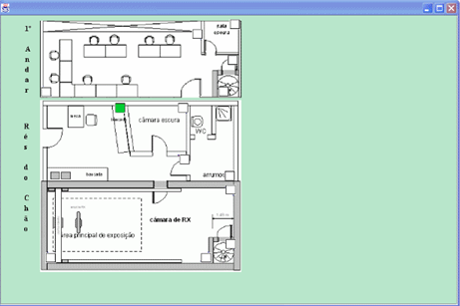
If a pre-alarm situation occurs, the cell turns to yellow and a local beeper should sound to warn the person present of the eminence of an alarm if no motion is detected (this feature is not foreseen in the final implementation).
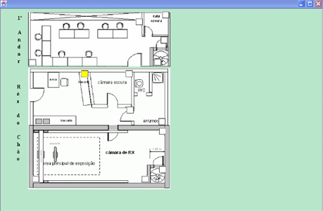
Finally, if an alarm state is reached, the yellow dot turns to red dot, the imaging section of the window will go active with the picture from the camera assign to the sensor, if that is the case, and a sound alarm is activated in the control room.
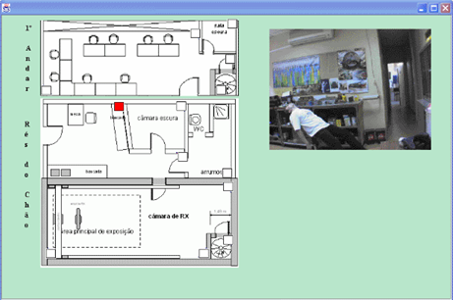
In case of multiple alarms in different cells, the system will present the image from the sensor with a camera assigned to it, or in the case of both sensors having cameras assigned to them, the operator can choose witch camera to look to by pressing the correspondent sensor red dot.

8. Conclusions and Further Work
In this paper we synthesized several aspects of the FPIAA system. The system is composed of hundreds of sensors distributed among the ATLAS dangerous areas to monitor the presence of persons and reduce the time needed to look for a missing person in case of alarm. To achieve this goal several challenges should be overcame:
One of the main challenges in this project were the user friendliness of the system which obliged us to not force the users to use any special device. RFID [Want 2003] could be in the base of a good technical solution, could not be used because they would impose to the persons the use of some device. This problem was solved by using COTS PIR sensors which are passive and detect persons movements.
Another important challenge was the need to make the sensors work in such hostile environments plenty of radiations and under strong magnetic fields. These problems were solved by a careful exam of the components of the sensor and their replacement by equivalent components which were known radiation hard.
The software made for handling the sensors and the state of the different cells was the solution we found to avoid false alarms when a person is not moving. A local generate alarm would inform the person about the eminence of an alarm. Only if a person still does not react a general alarm would be generated.
Further work for this project includes:
- The definition of the sensors location to cover all the protected areas.
- The adaptation of the prototype software to the CERN existing Data Control System.
- The installation of a pilot site for exhaustive tests with the sensors, persons and the FPIAA system.

References

[Atlas 1994] ATLAS Collaboration, “ATLAS Technical Proposal for a general purpose pp experiment at the Large Hadron Collider at CERN”, CERN/LHCC 94-43, 15 December 1994.
[Burckhart 1998] H.J. Burckhart, “Detector Control System”, Fourth Workshop on Electronics for LHC Experiments, Rome, (Italy), September 1998, p. 19-23.
[Burckhart 2001] H.J. Burckhart et al., “Communication between Trigger/DAQ and DCS”, International Conference on Computing in High Energy and Nuclear Physics, Beijing, (China) September 2001, p. 109-112.
[Kate 1999] Ten Kate, “Superconducting magnet system for the ATLAS detector at CERN”, IEEE Transactions on Applied Superconductivity, Volume: 9, Issue: 2, pp. 841-846, June 1999.
[Want 2003] Want, Roy, “RFID a key to automate everything”, Scientific American, January 2004, pp. 56-65.

ELMB – Embedded Local Monitor Board (http://elmb.web.cern.ch/ELMB/ELMBhome.html)
CANBus - (http://www.mjschofield.com/)
CAN - (http://atlas.web.cern.ch/Atlas/GROUPS/DAQTRIG/DCS/CANINFO/canhard.htm)
Java Home: http://java.sun.com/

